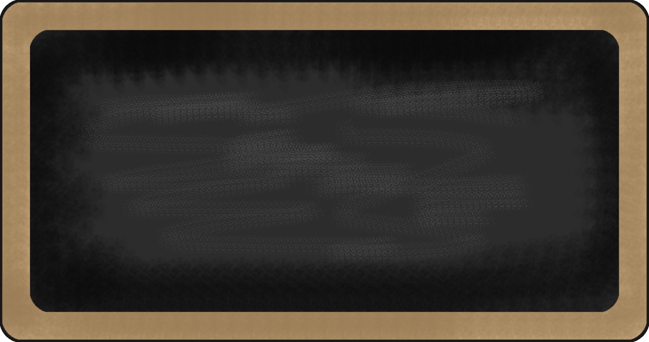
Sight Words

- go
- my
- run
- blue
- for
- little
- not
- said
- two
- yellow

Mrs. Damren and Mrs. Baxter’s News: September 14, 2015

Upcoming events

September 14th first CARE club meeting
September 21-25 Fall Break
September 28th Care Club meeting
October 2nd Movie Night on the Lawn
October 15th Spirit Night at Yogli Mogli
October 23rd Annual Monster Mash Fall Festival

reading | Writing | Word | Math | Science | Social studies
- Horton Hears a Who | - Vocabulary from book | - Moon | - Identifying numbers  - adding | - Moon Phases | - Social interactions  

Notes from the teacher:
*New to class: Homework folders!
*Students must be in class by 8:00 or they will be counted tardy.
All parents must check in through the front office anytime they visit the school. Please look for visitor stickers.
Please practice sight words with your students nightly!

Happy Birthday to:

What we are learning this week:

Contact Information Mrs. Damren 770-443-8060 rdamren@paulding.k12.ga.us


